**COMSATS University Islamabad**

**Attock campus**

**Program: BSE**

**Name: Qurat-ul-Ain Bibi**

**Registration #: SP23-BSE-032**

**Course: DS-Theory**

**Date: 24-09-2024**

**Assignment #: 01**

**Submitted To: Sir Muhammad Kamran**

**Introduction:**

The objective of this assignment is to design and implement a task management system using a singly linked list. The system allows users to add new tasks, view all tasks, remove the highest priority task, and remove a task by ID.

**Code Explanation:**

**1. addTask()**

Adds a new task to the linked list, maintaining priority order. Checks for duplicate task IDs and inserts the new task at the correct position based on its priority.

**2. viewTasks()**

Displays all tasks in the linked list, printing task ID, description, and priority level for each task. Traverses the list from the head node to the end.

**3. removeHighestPriorityTask()**

Removes the highest priority task from the linked list by updating the head pointer to the next task. Assumes the list is not empty.

**4. removeTaskById()**

Removes a task by its ID from the linked list. Traverses the list to find the matching task, updates pointers to maintain list integrity, and deletes the task.

**5. main()**

Serves as the program's entry point, presenting a menu-driven interface for users to interact with the task management system. Handles user input and calls corresponding functions.

**Challenges Faced:**

During the development of the task management system, I encountered a challenge that user can enters the duplicate id which a posing a problem in removeTaskById() method as i have identical ids:

**Solution:**

I have Added a duplicate ID check in the addTask method to prevent users from entering identical IDs.

**Conclusion:**

Through this assignment, I gained hands-on experience implementing a singly linked list to manage tasks. Developed essential functions for task management: adding, viewing, removing, and searching tasks. This project allowed me to apply theoretical concepts to practical problems.

**Code:**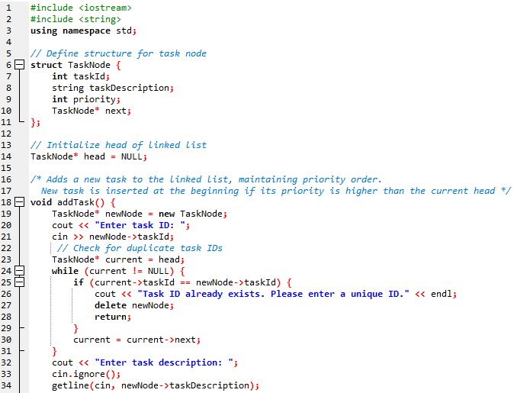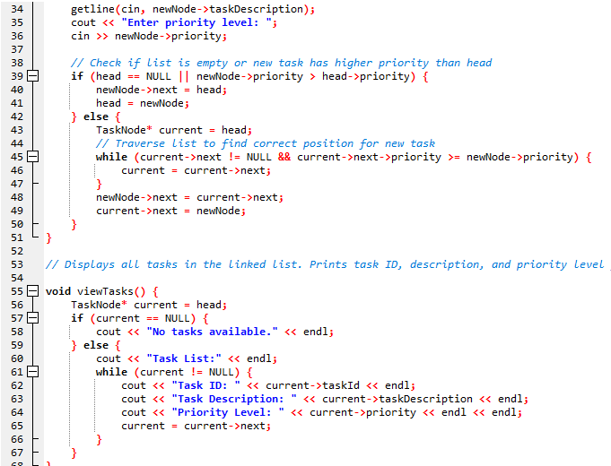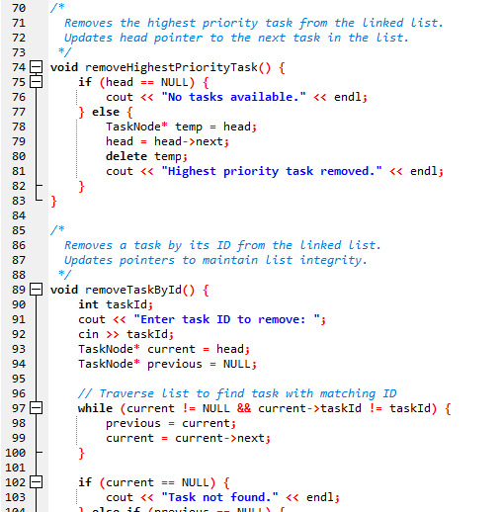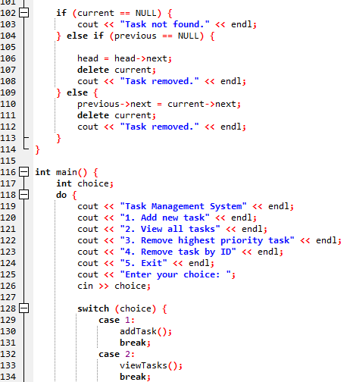

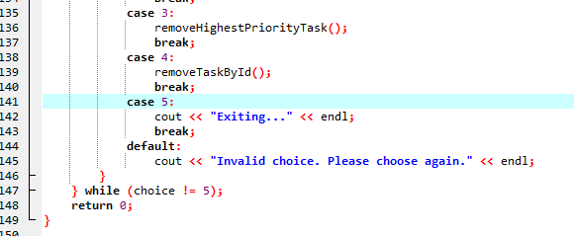

**OUTPUT:**

